**Setting up VPC and SG for Hosting Instance on Cloud**

Contents

**Scenario** 3

**Objectives** 3

**Lab Setup** 3

1. Create VPC 4

2. Setting up a new Security Group 7

# **Scenario**

This lab guide will help you in setting up VPC and SG for hosting instance on Cloud.

# **Objectives**

After you complete this lab, you will be able to:

* Install all required dependencies
* Install and Configure Database
* Start Database Service
* Install and Configure Web Server
* Start Web Server
* Test

# **Lab Setup**

* *Estimated Time*: 45 minutes

Before you begin this lab, you must complete the following step:

* Set up and configure on-premise UBUNTU 16.04 instance on your laptop or desktop

# Create VPC

**Step 1:** Log into AWS dashboard using your credentials.

**Step 2:** In search box, type VPC and go to VPC dashboard

**Step 3:** Click on launch VPC wizard for setting up new VPC

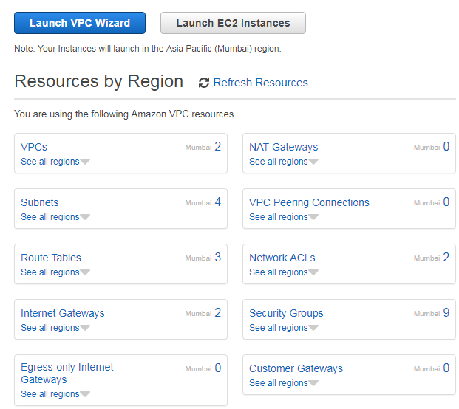

**Step 4**: Select first option of setting up VPC with single public subnet

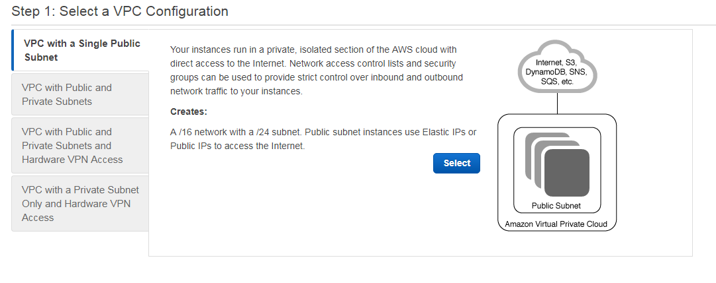



**Step 5:** Type the CIDR block and name for the VPC and click create VPC

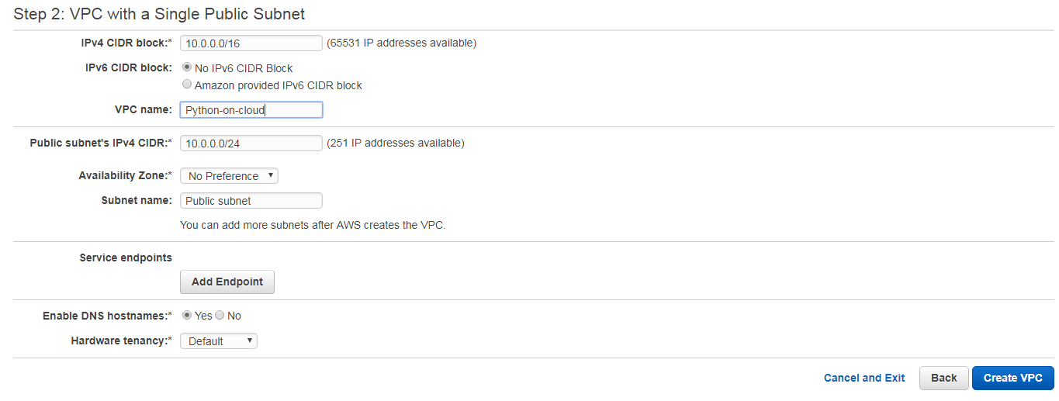

**Step 6:** Observe the VPC is created. Click OK.



# Setting up a new Security Group

**Step 1:** On the VPC dashboard left panel, search for **Security** tab and click **Security Groups**

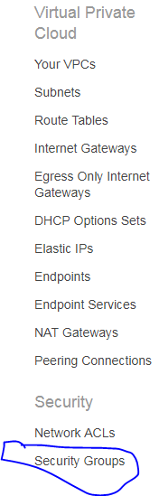

**Step 2:** Click Security Groups

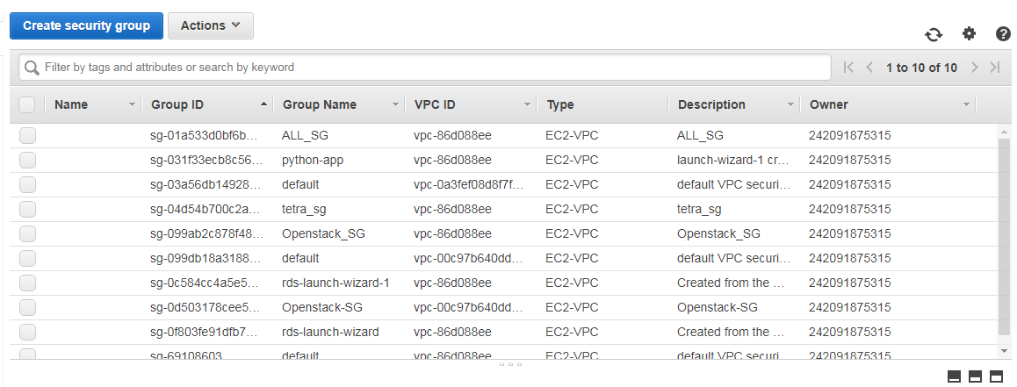

**Step 3**: Type the name of your security group and select the VPN in which you want to use the security group and click on **Create**

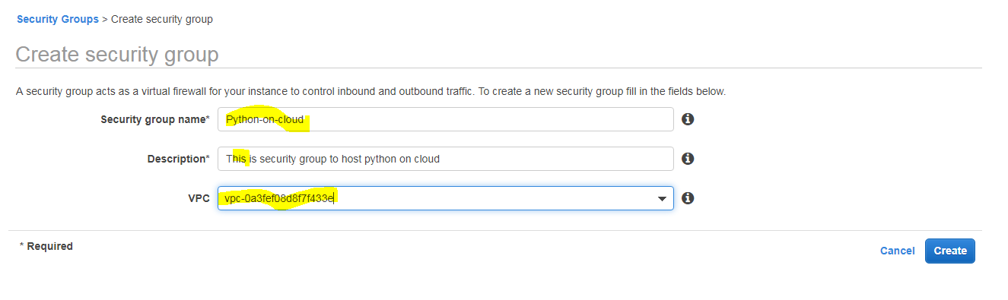

**Step 4**: Edit your security group and select newly created SG and click **Edit**

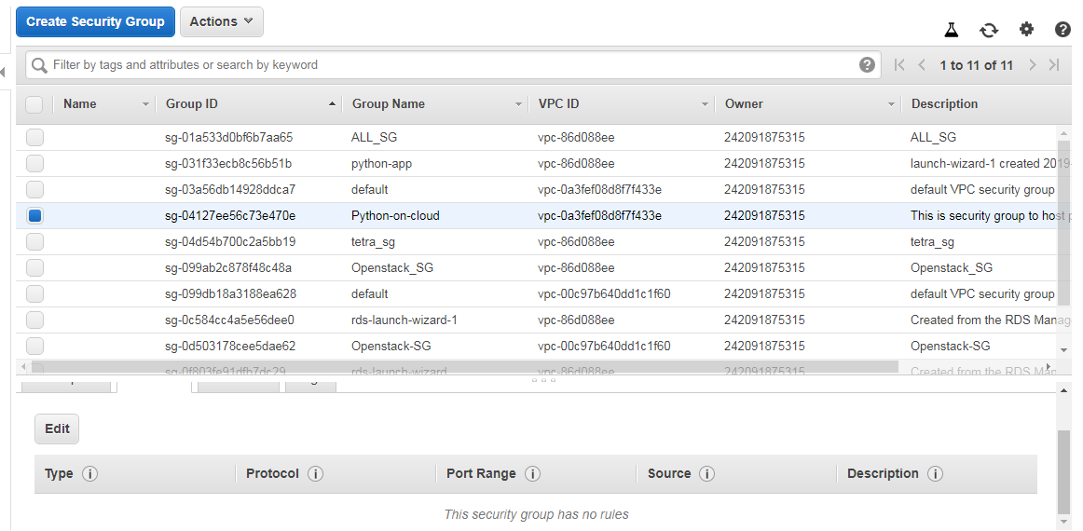

**Step 5**: In the inbound rules, select the rule of your choice for hosting your application and click **Save**

